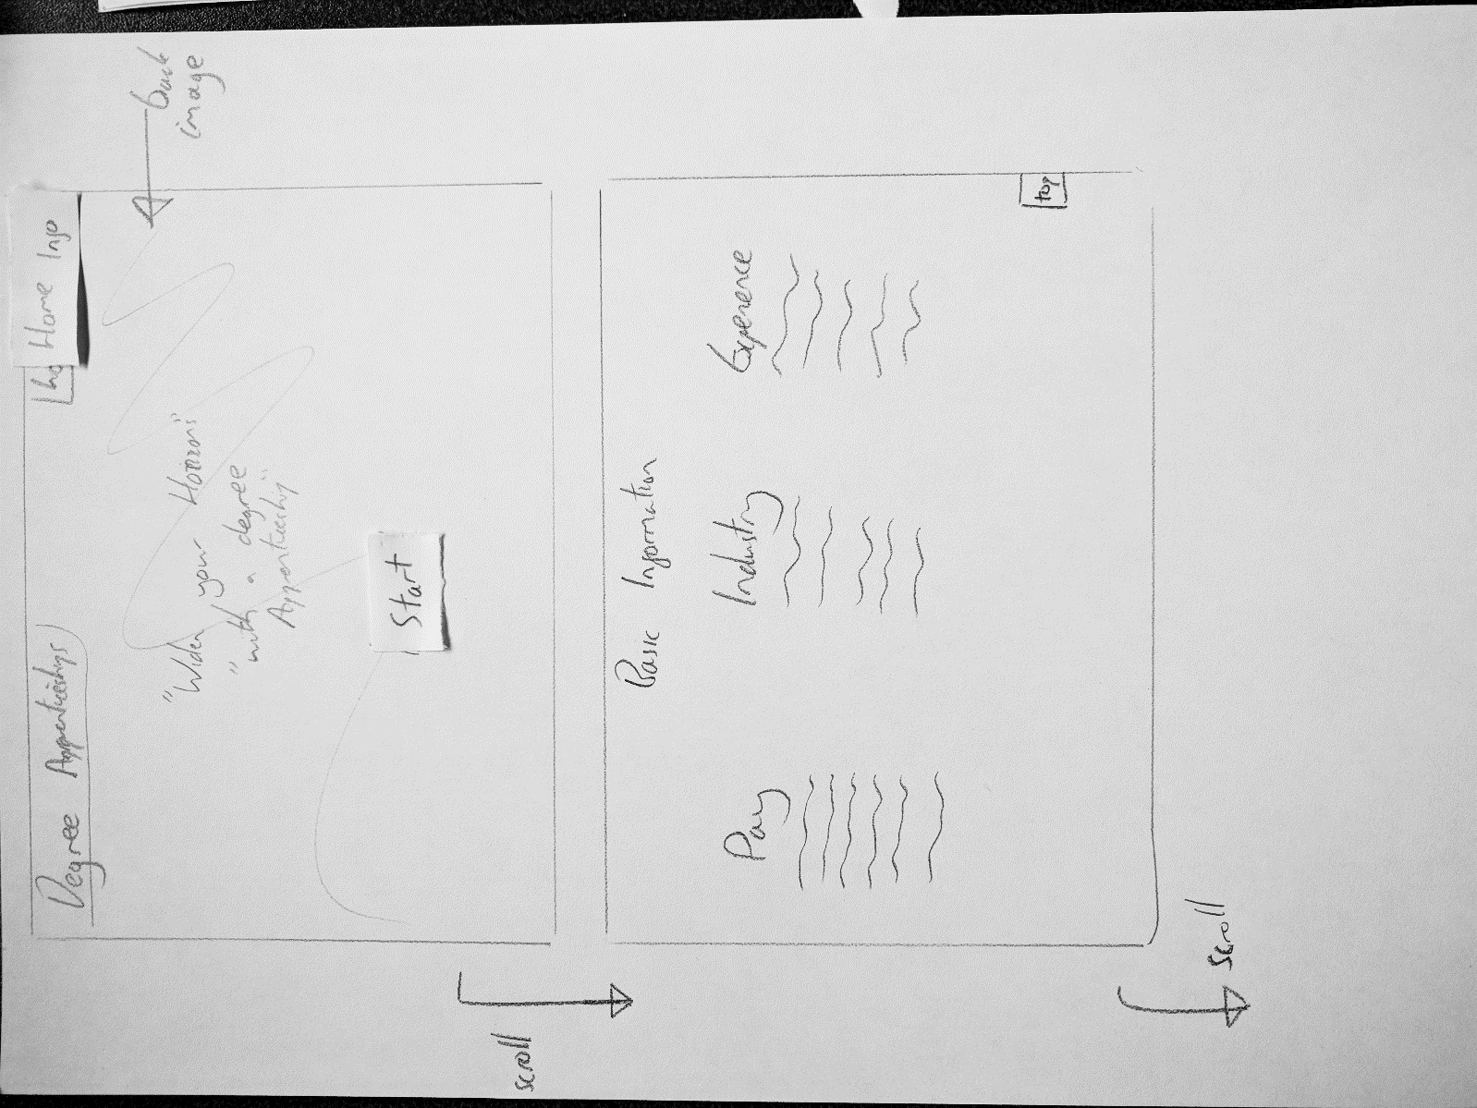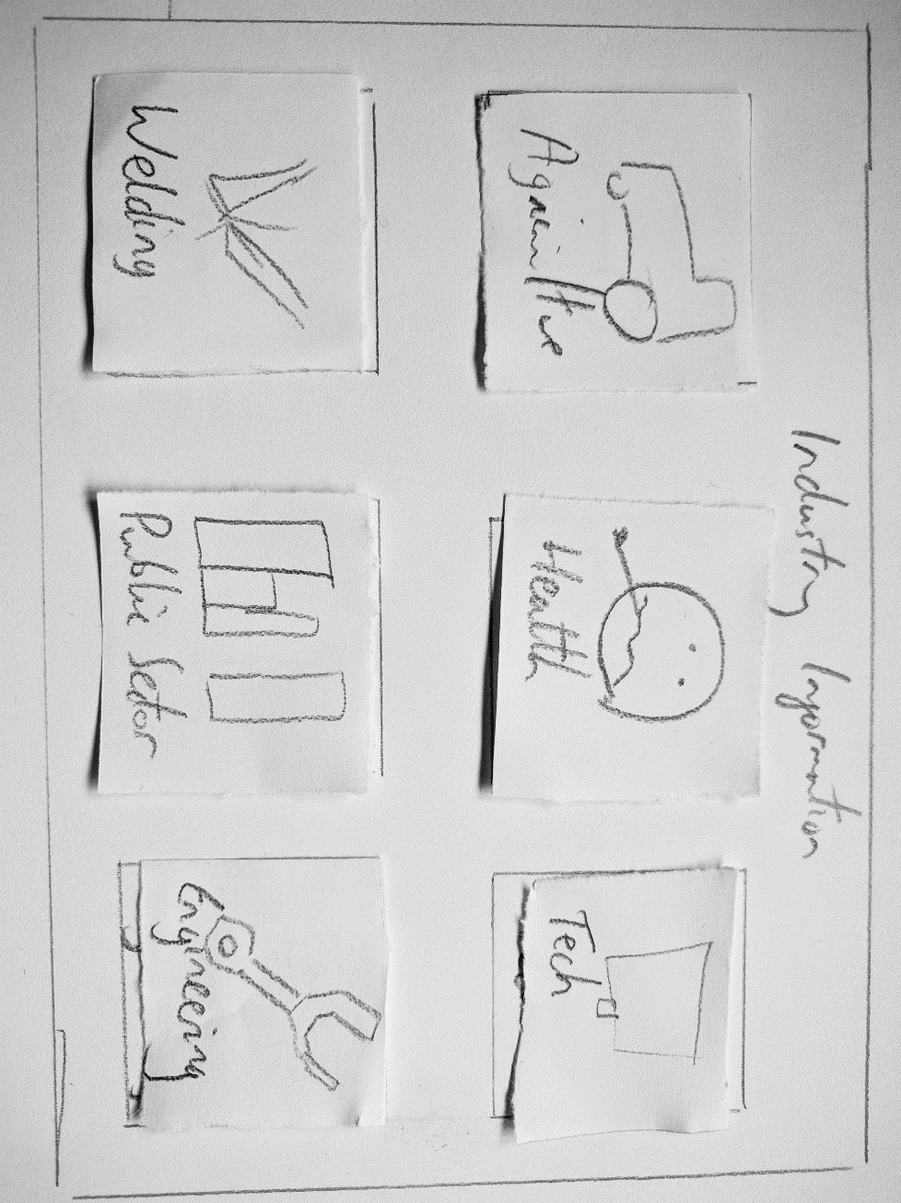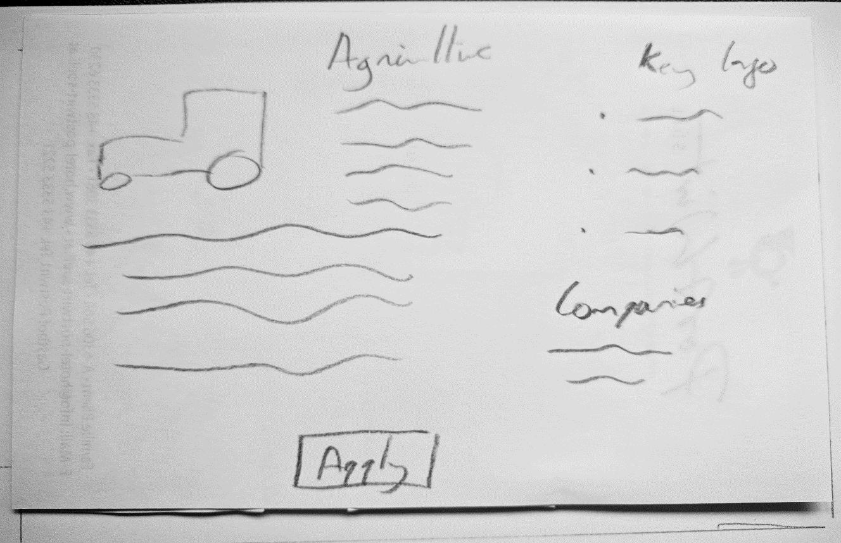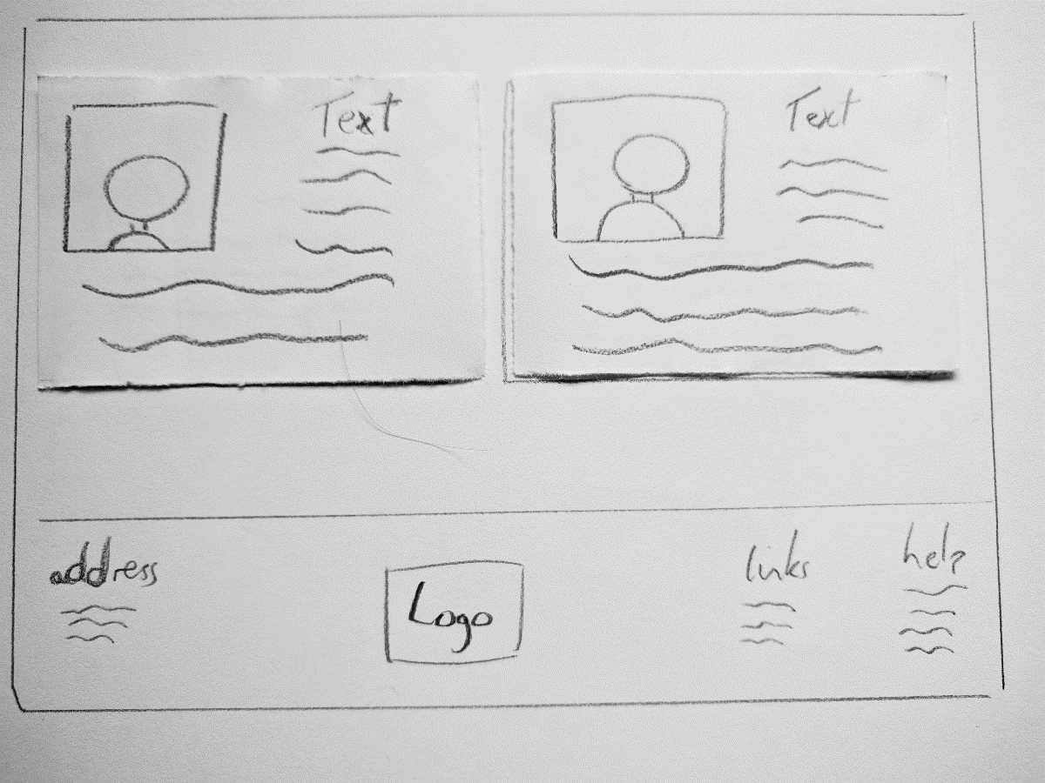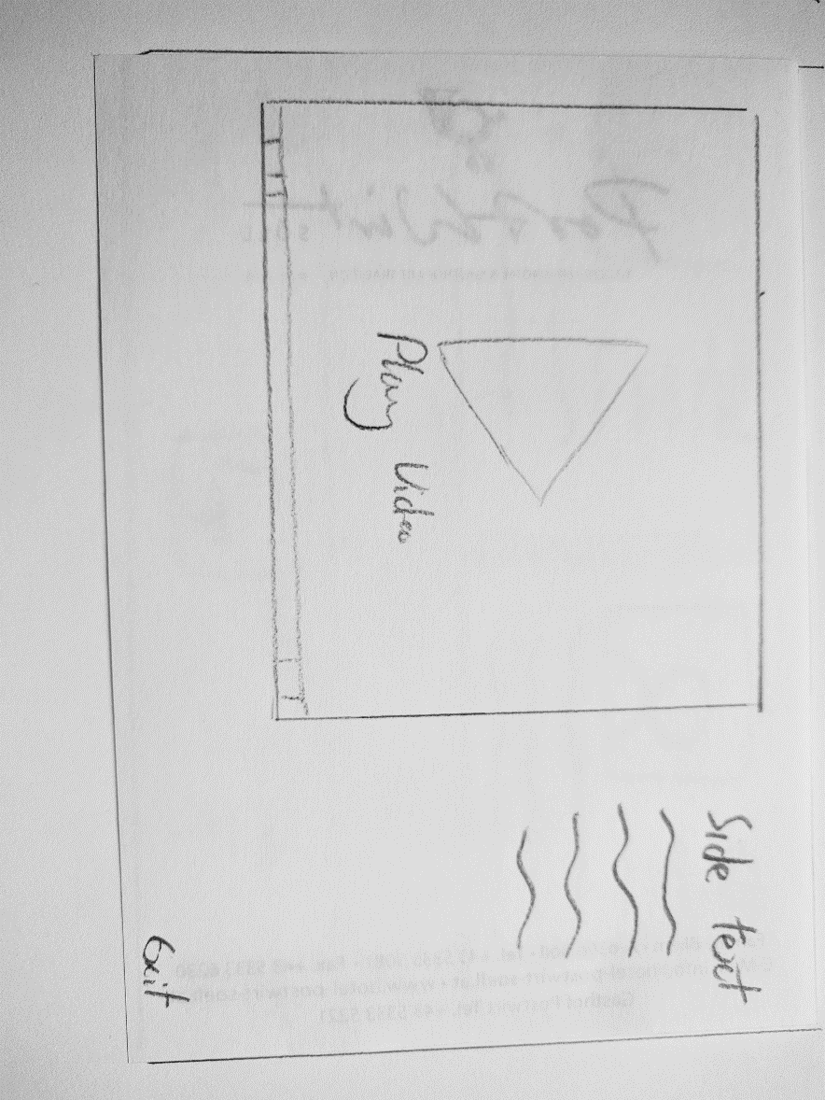

Scrolling reveals a simple page with 3x text panels.

Background image covering most of page. Clicking the “Start” button scrolls to the lower page

Paper Prototype – Design 2

Scrolling reveals a new page with clickable panels

Clicking on a panel reveals a new panel with detailed information filling the screen

There is also a footer with basic links on it to allow for easy navigation

Scrolling to the very bottom reveals a final page, which contains clickable cards with case studies on them

Clicking on these cards reveals a new card which fills the screen – with information on videos